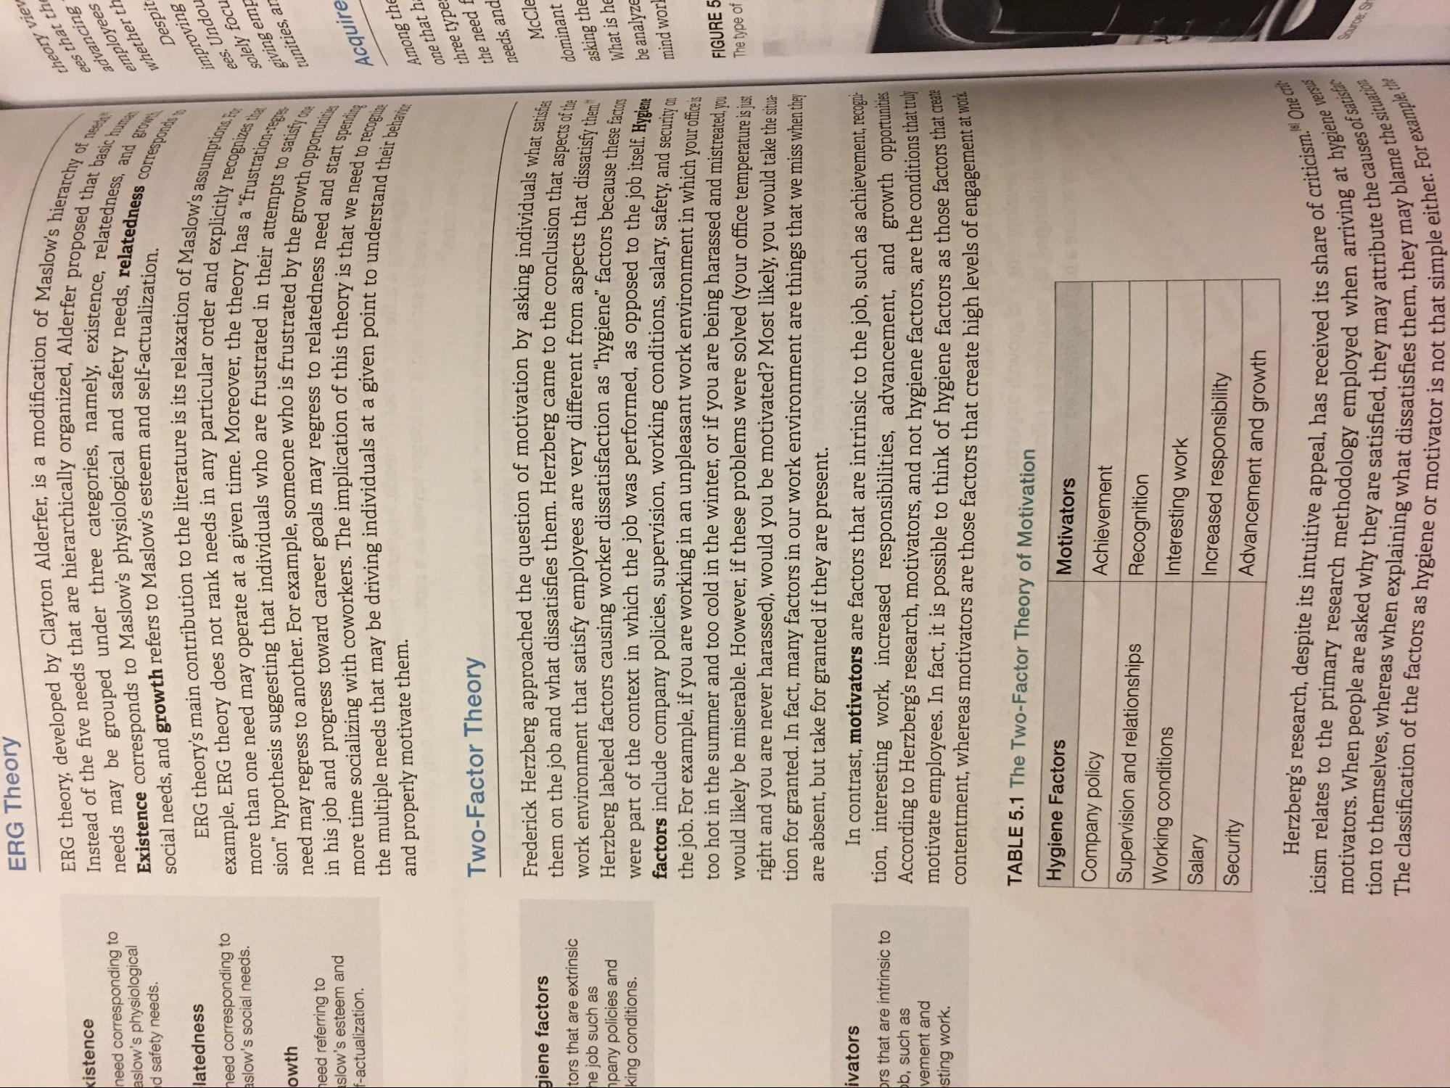
ERG Theory
kistence need corresponding to aslow's physiological id safety needs.
sation of Maslow's hierarchy
Alderfer proposed that bas v existence, relatedness, sty needs, relatedness corre
d self-actualization.
- hat basic huma ors and grow
Corresponds
ERG theory, developed by Clayton Alderfer, is a modificatio Instead of the five needs that are hierarchically organized, Alder needs may be grouped under three categories, namely, existe Existence corresponds to Maslow's physiological and safety social needs, and growth refers to Maslow's esteem and self-actualis
ERG theory's main contribution to the literature is its relaxation example, ERG theory does not rank needs in any particular ordera more than one need may operate at a given time. Moreover, the them sion” hypothesis suggesting that individuals who are frustrated in a need may regress to another. For example, someone who is frustrated in his job and progress toward career goals may regress to related more time socializing with coworkers. The implication of this theory is the multiple needs that may be driving individuals at a given point to and properly motivate them.
theory ees that advancir employe whether
Desa improvir ees. Und solely fo giving en
latedness need corresponding to aslow's social needs.
y recognizes that
tunities,
owth need referring to islow's esteem and f-actualization.
to satisfy one
nuation of Maslow's assumption ular order and explicitly recos
he theory has a "frustration
d in their attempts to satisi strated by the growth opportu
tedness need and start spen eory is that we need to recoon bint to understand their behavia
hopportunities
Acquir
Among tł one that
Two-Factor Theory
three typ the need needs, an
McCI
giene factors tors that are extrinsic he job such as
pany policies and king conditions.
dividuals what satisfies
clusion that aspects of the m aspects that dissatisfy them
dominant asking the What is h be analyze
these factors
If. Hygiene
curity on
mind wor
Frederick Herzberg approached the question of motivation by asking individual them on the job and what dissatisfies them. Herzberg came to the conclusion the work environment that satisfy employees are very different from aspects that dicen Herzberg labeled factors causing worker dissatisfaction as “hygiene" factors because were part of the context in which the job was performed, as opposed to the job itself factors include company policies, supervision, working conditions, salary, safety, and secure the job. For example, if you are working in an unpleasant work environment in which your office too hot in the summer and too cold in the winter, or if you are being harassed and mistreated you would likely be miserable. However, if these problems were solved (your office temperature is just right and you are never harassed), would you be motivated? Most likely, you would take the situation for granted. In fact, many factors in our work environment are things that we miss when they are absent, but take for granted if they are present.
In contrast, motivators are factors that are intrinsic to the job, such as achievement, recogni. tion, interesting work, increased responsibilities, advancement, and growth opportunities According to Herzberg's research, motivators, and not hygiene factors, are the conditions that truy motivate employees. In fact, it is possible to think of hygiene factors as those factors that cica contentment, whereas motivators are those factors that create high levels of engagement as
FIGURE 5 The type of
ivators
rs that are intrinsic to b, such as vement and sting work.
t at work
TABLE 5.1 The Two-Factor Theory of Motivation Hygiene Factors
Motivators Company policy
Achievement Supervision and relationships Recognition Working conditions Salary
Interesting work Security
Increased responsibility Advancement and growth
criticism. One cribe
at hygiene versus
causes of satisfac
Herzberg's research, despite its intuitive appeal, has received its shar icism relates to the primary research methodology employed when motivators. When people are asked why they are satisfied, they may attri tion to themselves, whereas when explaining what dissatisfies them, they The classification of the factors as hygiene or motivator is not that s
attribute the causes of sa 2, they may blame the situat
-. For example the
is not that simple either. For ex

